Site Heuristic Evaluation

Assignment 3

GIT 542 Usability

Douglas Swanson

[www.spacefoundation.org](http://www.spacefoundation.org)

Evaluation of The Space Foundation Site

For this heuristic evaluation of the space foundation website, Nielsen’s 10 points of usability. These 10 points are as follows:

1. Visibility of system status.
2. Matching the system to the real world.
3. User control and freedom.
4. Consistency and standards.
5. Error prevention.
6. Recognition instead of recall.
7. Flexibility and efficiency of use.
8. Aesthetic and minimalist design.
9. Assist users in recognizing, diagnosing, and recovering from errors.
10. Help and documentation.

The site in question will receive a rating for each of these 10 points. The rating system for this evaluation is based upon a system was developed by Rolf Molich and Robin Jeffries (Sauro, PHD) and is heavily based on the amount of time it takes to complete a task. Their system uses 3 tiers, seen in the table below, which, in my opinion, greatly increases the speed and accuracy of the evaluation because there is less time spent evaluating an issue that is more than just annoying but not completely catastrophic.

|  |  |
| --- | --- |
| Rating | Description |
| None (0) | The site accurately achieves its goal in a timely manner and the user can complete the process in question without any distraction. |
| Minor (1) | A minor inconvenience that delays that briefly delays the user in their task or briefly takes the user from current process. |
| Serious (2) | An inconvenience that significantly delays the user, but the task remains completable or it completely sidetracks the user from the current process. |
| Catastrophic (3) | The user cannot complete the task or process at all. |

Visibility of System Status

The site has a few place where system status is used, the first being the Donation page (<https://www.spacefoundation.org/donate/together/> ). While filling out the form in used to make a donation the form updates when a selection is made and has tool tips appear when some of the options are hovered over to indicate additional information about the option.

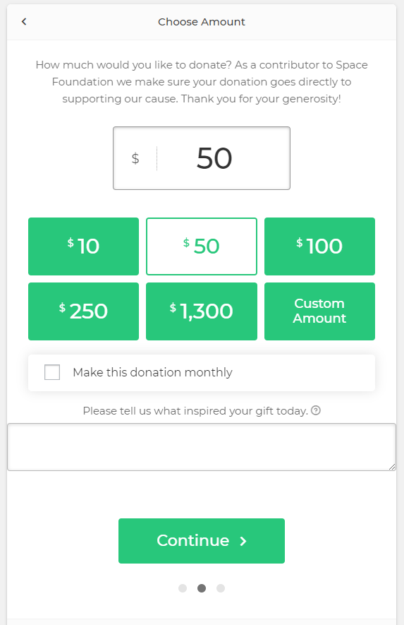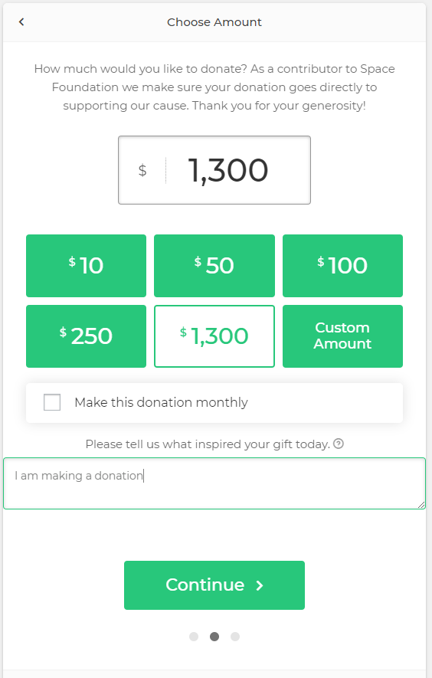

Another is on the bottom of the certification page (<https://www.spacefoundation.org/get-certified/> ) where it is asking for contact information from the user that will be used to start a person-to-person conversation at a later time. This form will update the user as they are filling out the form when an error has been made which is telling them the status of the form as they use it.

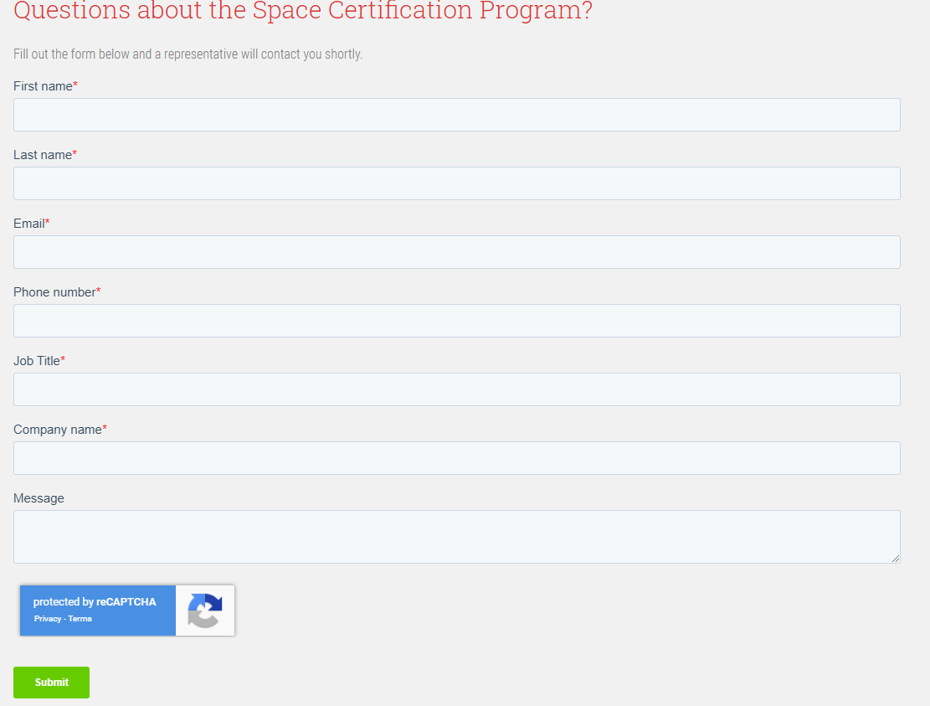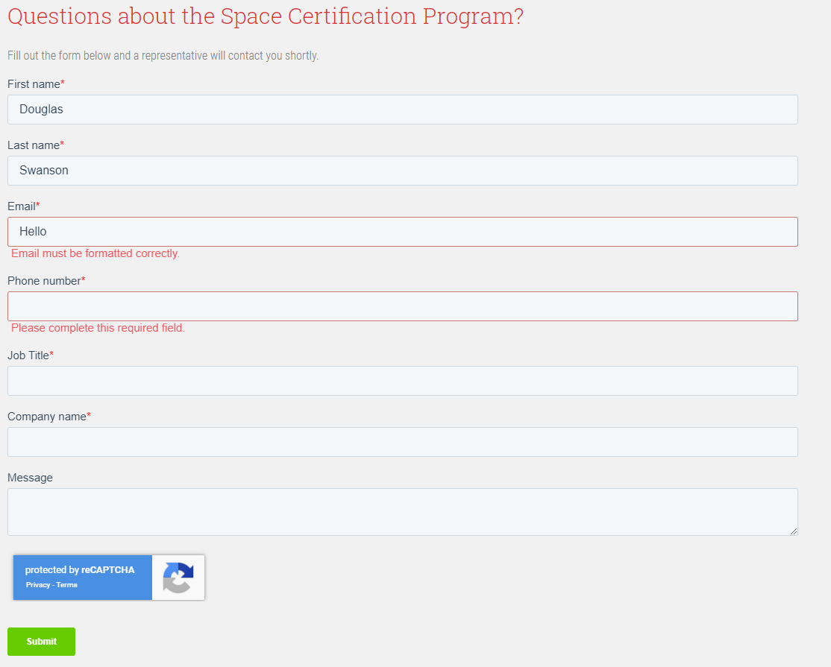

The space foundation site receives a score of 1 or minor for this heuristic because the forms used on most of the pages update as the user types of information into them except for the third page of the donate form that asks for the user’s payment data. That form only validates the information within the form once the information has been submitted.

Matching the System to the Real World

While navigating through the massive amounts of information presented by the space foundation site you notice that the pages represent reading an article in any other form of media. The forms take on the same form as filling out a similar form on a piece of paper.

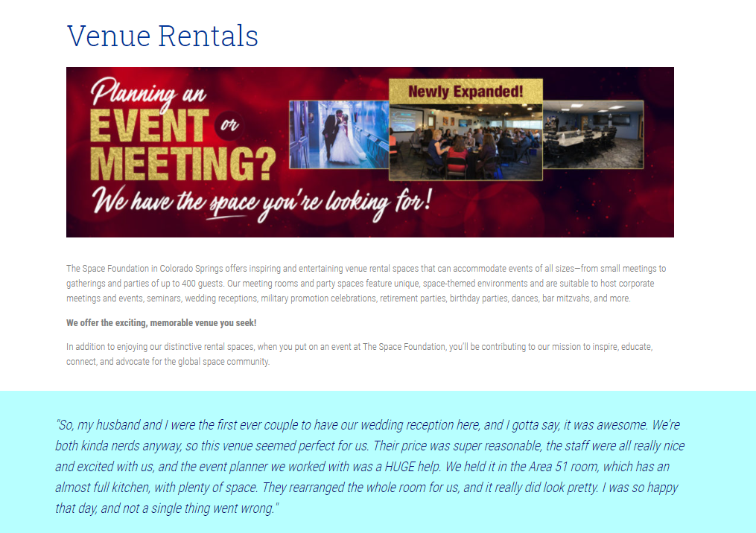

The space foundation site receives a score of 0 or none for this category.

User Control and Freedom

User control and freedom mean that the user should be able to navigate around the site without ever having to hit the back arrow or reloading a page. The space foundation site does a good job of this when you navigate to one of the event sites linked in the upper navigation bar by having a common navigation bar across the sites, as seen below. This common bar makes is amazingly easy to return to the site that you were redirected from.



Unfortunately, it does have an issue when reading the State of Space page because it interrupts the user from reading the page or navigating around the site by locking the user’s view with a form asking them to sign up to view the web conference. There wasn’t a was to get the form to disappear and regain control versus backing out of the page using the back button.

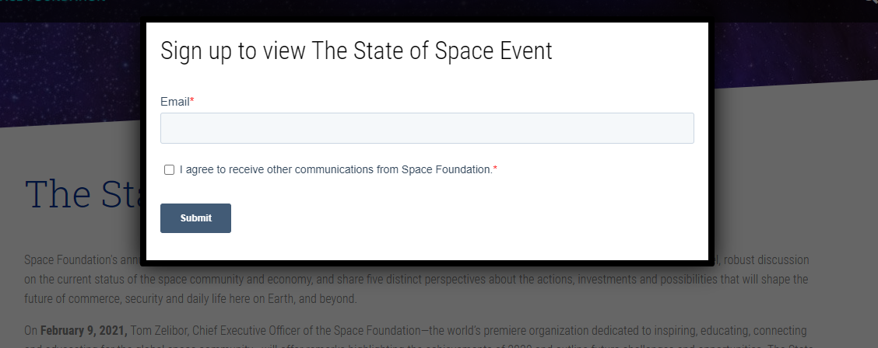

Due to this last issue the Space Foundation site receives a 2 or Serious rating because it prevented the user from finishing their task without reloading the page the view the rest of the information.

Consistency and Standards

The pages that make up the space foundation site are consistent in their form, fonts, and format (as can) been seen in the images in the aesthetic section below. This site uses the modern website standards to create and display information to the user. This can been seen in the location and function of the space foundation logo in the upper lefthand corner of every page. There are also the standard pages used in the site such as a contact page, a search feature, and an about us section to name a few. The site receives a score of 0 or none in this regard.

Error Prevention

All of the forms used within this site have error protection built into them. The protection is validating the user input to make sure that it is the correct type of data required by the specific field of the form.

 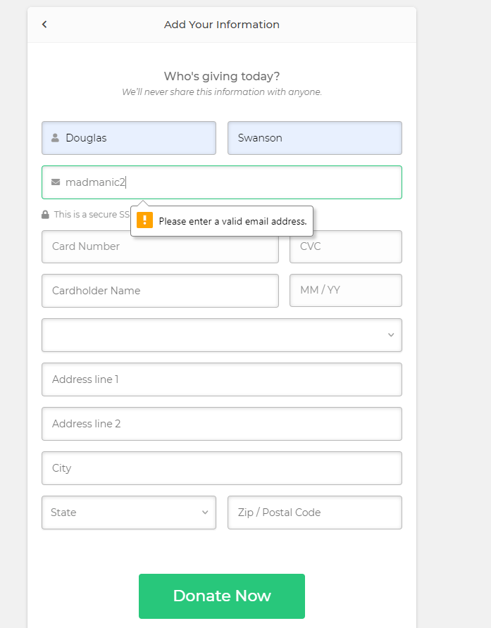



This heuristic is scored with a value of 0 or none, due to all the forms having the error prevention built into them and the site uses a 404 (and quite possibly other error) pages.

Recognition Instead of Recall

As a user navigates around the site they will stumble upon a few controls that use recognition to inform them of their function. The spyglass icon indicates search the site for something. Each of the categories in the navigation bar have an arrow indicating that clicking here will bring up subcategories in an expanding menu. The buttons use a contrasting color and a phrase that will indicate the consequence of selecting the button in question.

  

Due to these recognition elements the site receives a score of 0 or none.

Flexibility and Efficiency of Use

Aesthetic and Minimalist Design

One thing that the space foundation site has going for it is it’s Aesthetic design that is carried across all of the pages on the site but also through all of the event sites linked to within this site. Now, the site cannot be called minimalist due to the shear amount of information it is trying to convey to it’s users. Each and every page on this site is just loaded with related data, and I do believe that the developers did thin down this information. This is still overwhelming but it is well organized and it does allow the user to digest the information in smaller chunks.

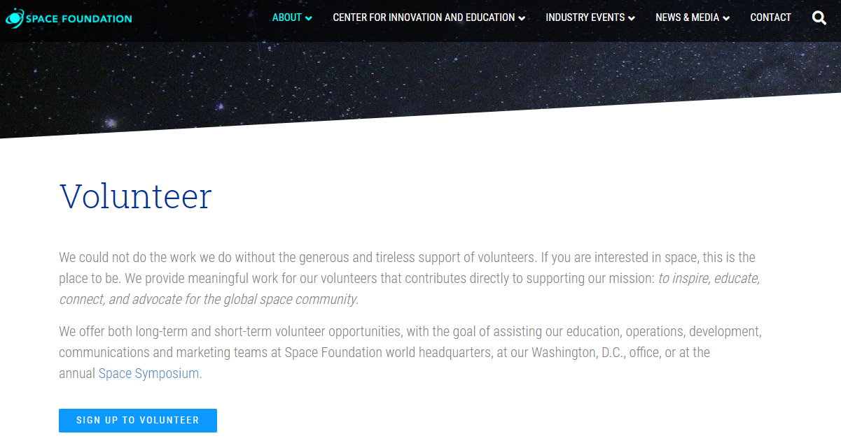 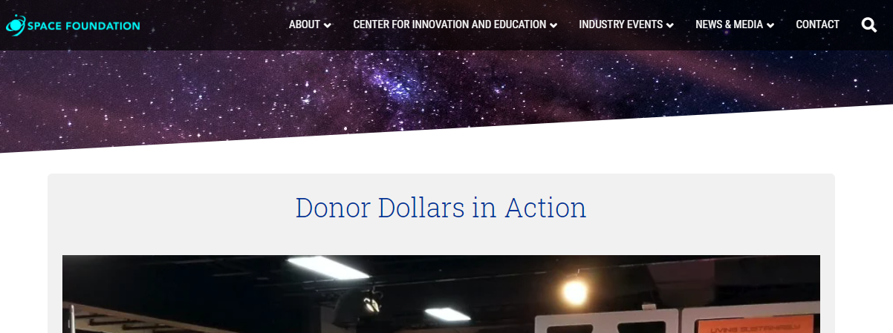

The site has received a score of 1 or minor for this heuristic.

Assist the Users in Recognizing, Diagnosing, and Recovering from Errors

The forms used across the site give information to the user upon the errors that occurred within the form. These allow the user to recognize the error (highlight in red), diagnose (error text underneath), and recover by entering the correct information. On the other hand the 404 page just says something has gone wrong without providing additional information on what the error was or allowing the user to easily navigate back to a landing point within the site. This error page has given this heuristic a score of 1 or minor.



Help and Documentation

The site has a contact us page which allows the users to reach out and contact the site leadership or maintainers. But it is just and informational site so there isn’t any documentation or specific help for each page.

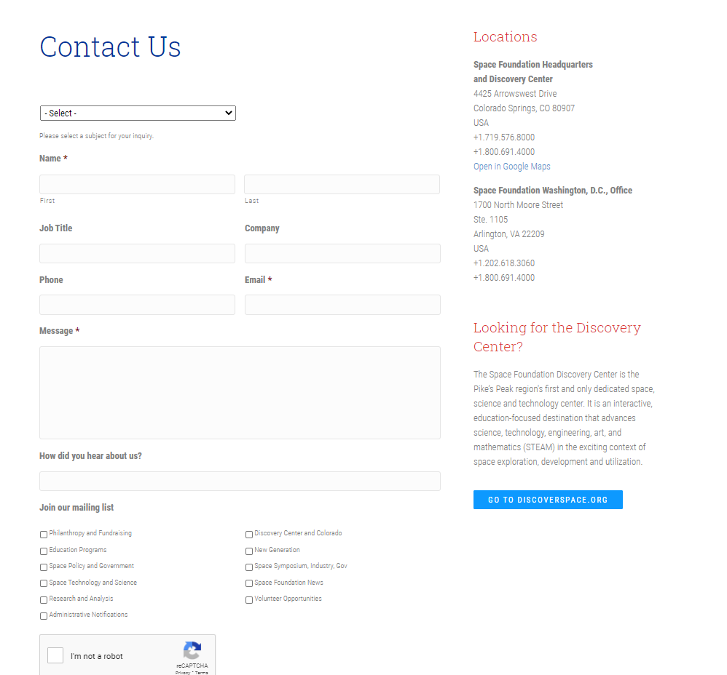

This site has received a score of 0 or none for this category.

Bibliography

1. Naray, Andrew de, and Space Foundation Editorial Team. “CIE Homepage.” *Space Foundation*, 6 May 2020, www.spacefoundation.org/.
2. Sauro, PHD, Jeff. *Rating the Severity of Usability Problems*. 30 July 2013, measuringu.com/rating-severity/.